Muhammad Aamir Khan

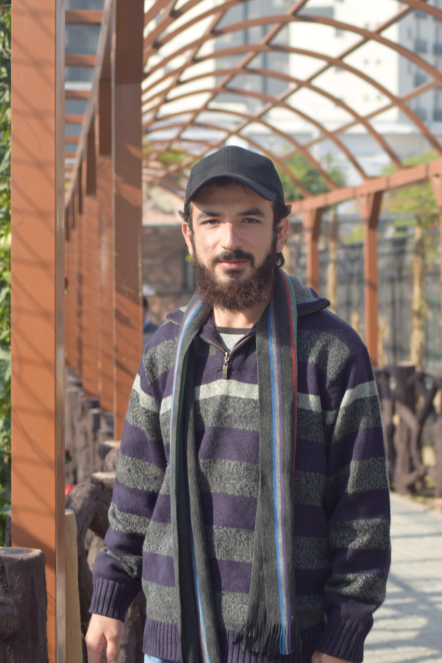

Contact

**Address:**

Dera Ismail Khan (KPK)

**Phone:**

+92 3479325167

**Email:**

aamirk2244@gmail.com

Hobbies

Cricket

Books

Coding

Learning

Traveling

Education

Bachelor of Science:

**Computer Science –** 2022 (CGPA 2.58)

**FAST University**

Skill Highlights

|  |  |
| --- | --- |
| * Programming Languages * Software Development * Full Stack Development * Android development | * Linux and Windows OS * Docker * Software Testing * Artificial Intelligence * Databases,Mysql and Mongodb |

Projects

**School Management System** -

* Created a School Management Software in semester Project using **Java** + **JavaFX** + **Swing** + **Mysql**. [**https://www.youtube.com/watch?v=qahjQOqnWhk&t=1s**](https://www.youtube.com/watch?v=qahjQOqnWhk&t=1s)**.** Here is the short review of project on my YouTube channel.

**Banking System** -

* Banking system in CPP with Graphics.h Library. [**https://youtu.be/N0HgM8FWpAI**](https://youtu.be/N0HgM8FWpAI). Here is the short review of my project.

**Banking System II** -

* Banking System in **Java** + **JavaFX** + **Mysql**.
* Complete detailed programming and development tasks for front end public and internal websites as well as challenging back-end server code.

**Digital Clock** -

* Created a Digital Clock in Assembly Language.

**Short Path Finder** -

* Created a project for Finding a Short path to Destination from current City using **Python.**

**Blood Donation System -**

* Created a database Project for the Blood Bank using **Mysql** + **Php** + **Html** + **Css**.

Website and Others

**Website:**

<https://aamirk2244.wordpress.com/>

**GitHub:**

<https://github.com/aamirk2244/>

**YouTube:**

<https://youtube.com/channel/UCOf34-tx93QYwYiQxkVnsqg>

**Linkedin:**

https://www.linkedin.com/in/muhammad-aamir-khan-b14906194